Turning the spotlight on yourself

How do you turn the spotlight on yourself? We all approach decision-making in different ways, influenced by various factors, such as our personality, how those around us make decisions, how confident we feel, how independent we are, the pressure we’re feeling, and the extent we feel destiny plays a part in life. Whichever is important to you, here are some steps you can take to help discover what matters most to you.

Activity 1 – Organise it. Design it. Make it yours.

To work out what’s right for you you’ll need to get organised – so start by creating your UCAS Hub. It will give you all the tools and information you need – in one place!
Based on what you tell us, we’ll guide you to the information you need. You can easily explore and favourite the things which matter to you most, while you tick off things on your to-do list.

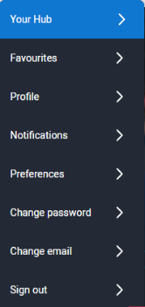
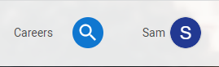
How do I sign up?
The UCAS Hub is free and easy to use. All you need to do is follow these three simple steps to sign up:
Step 1 – Register
To get started, visit ucas.com/hub.
Step 2 – Verify your account
Once you’ve completed your registration details you’ll be asked to verify your account by entering a code we’ve emailed you.
Just copy the code from the email and hit the verify button
Step 3 – Sign in
Now you’re ready to sign in and start exploring! The first time you do, we’ll ask you some extra questions so we can help you find the right info.
At any time, to pick up where you left off, click ‘Sign in’ on the top right-hand side of any page on ucas.com, and navigate to ‘Your hub’.
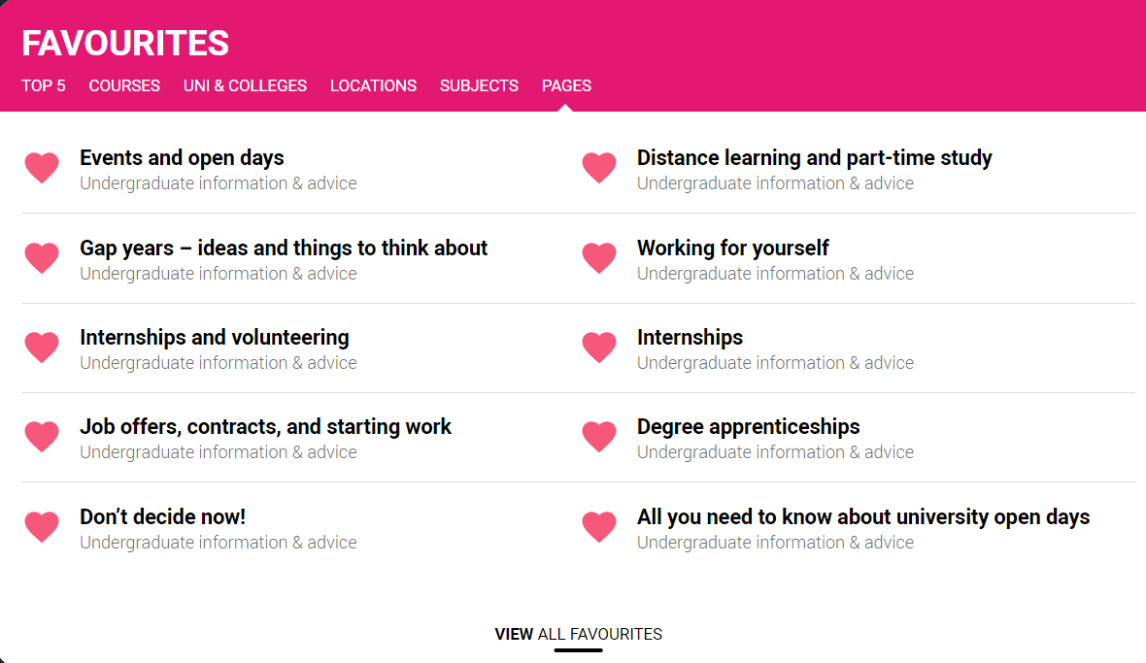
UCAS Hub top tip:
Favourite, favourite, favourite – you can store anything you find in the Hub or on ucas.com in your ‘Hub Favourites’. Simply click on the heart icon (usually top right-hand corner) to come back to it easily at any time.
For these activities, you can favourite the information pages suggested below so you can easily visit them again. Remember to sign in before you start exploring!

Activity 1: Where are you now?

This is a good starting point – it’s about you, so think carefully about these questions and note down your thoughts or ideas.
• What are your interests?
(This could be hobbies, activities, sports, extracurricular, current affairs or subject areas.)

• What are your skills?
(The sorts of things you’re good at – use obvious skills, such as working with numbers, as well as softer skills, such as being organised.) Think about the skills you have that employers are looking for.

• What do you value?
(The things that are important to you, both in your social and study life. For example, family, work, socialising, personal interests, being active, money, structure, and flexibility.)

• What motivates you?
(The things you’re enthusiastic about, or encourage you to take action and get involved.)

• No idea at all?
Then have a go at the UCAS Careers Quiz for inspiration – find out about your strengths, how others may see you and what might interest you.

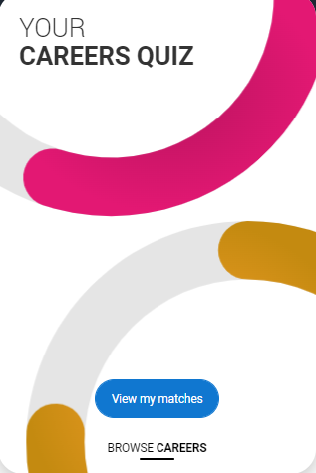
UCAS Hub top tip: Connect the dots between specific higher education courses and the perfect career. Answer questions to find out your personality traits and a percentage match to a range of different careers. You can then find out more about daily tasks, skills required, salary scales and more. The best bit is that we also show you university and college courses previous students completed in those sectors plus related careers. Remember to favourite anything you find interesting to come back to later!

Activity 2: What matters to you most in life?
A Flower Venn diagram – to help you blossom!
Corny? Yes… but don’t dismiss it straightaway – it’s a great way to figure out what matters to you most and where that fits. Finding the perfect balanced lifestyle is key to a happy and successful future.

Using what you’ve thought about so far, draw and fill in the five outer circles below.

What you love
What motivates you
What the world needs
What you can get paid for
Passion
Variety
Mission
Profession
Vocation
What you’re
good at
You and your purpose
Prompts:
Circle one: What you’re good at
Be specific and don’t think too hard. Use obvious skills such as presenting or writing, as well as softer skills such as being a good listener.
Circle two: What you love
This one is simple – the things that make you happy.

Circle three: What motivates you?
Consider what matters to you most in life – family, work, socialising, personal interests, being active, money, structure, flexibility?

Circle four: What the world needs
Think about how you fit into the bigger picture, and whether ‘making a difference’ in a wider sense is important to you.

Circle five: What you can get paid for
Write as many ideas as you can…

Activity 3: Where do you want to get to?

You may have a clear picture of what you want to do next, or what career you’re aiming for, or you may feel you haven’t got a clue and don’t know where to start. Chances are, you’re somewhere in between, so what ideas do you have?

• Are there any jobs or career areas you’re interested in?

(Find career ideas by exploring different jobs, taking our Careers Quiz, or looking at industry guides.)

• Are there subjects you love or ones you wish you could study?

(No idea? Check out our subject guides for ideas on courses you could study, what they involve, and how you could get on to them.)
• Do you have hobbies or interests you’d like to take further?

(Are there subject areas or industries they link to? Or use it to start your own business.)
• No idea at all?

Visit BBC Bitesize Careers to find out how other got into their dream careers. Then read about two very different ‘squiggly’ careers and hear from a motivational speaker about her ‘jigsaw career’.

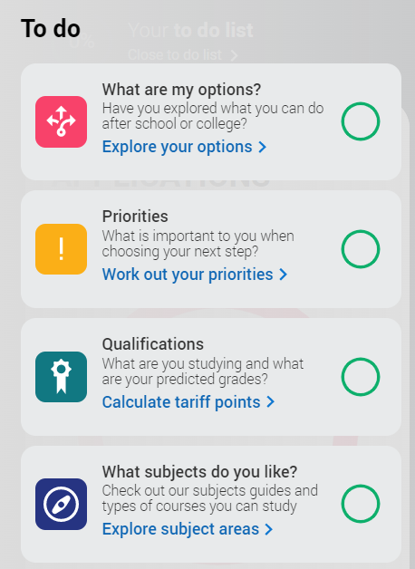
UCAS Hub top tip:
Use the ‘To do list’ to guide you – the more you tick on the list, the more suggestions we can make that might interest you to explore further.

Activity 4: What can I do next?

Now you’ve explored a little of what’s important to you and what you enjoy, you need to think about what to do next and what is best for you right now. Consider and compare each of the options below, plus what you’ve identified as important about yourself in the previous activities.
Use the links to help you find out more about each option and the questions to help you compare them.
What to do next? | University or college  What and where to study?  What’s a degree apprenticeship? | Doing an apprenticeship  Understanding apprenticeships  Real life stories from apprentices | Doing an internship  What is an internship?  Internships and volunteering | Gap Years  Ideas and things to think about  Studying abroad | Entering the world of work  Getting a job  What are employers looking for?
Three things I found out which I didn’t already know are…
The things I like most about this are…
The things I dislike most about this are…
Think about what following this route would mean for you over the short term (in the next year) and longer term (in the next five years).
The likelihood of me considering this, and researching it further is…
(Rank 1 – 10, with 10 being most likely.)

UCAS Hub top tip: Don’t forget to favourite any of the pages on ucas.com that you find interesting while you explore.
When you want to come back to them later, you’ll find them in ‘Your Hub’.

